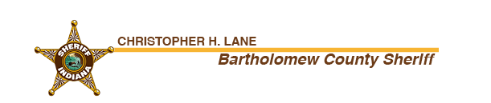

**Intoxicated man carrying shotgun arrested after standoff with deputies**

For Immediate Release: 01/15/2024

Contact: Sgt. Dane Duke – [dane.duke@bartholomew.in.gov](mailto:dane.duke@bartholomew.in.gov)

On 01/13/2024 at approximately 5:30 PM the Sheriff’s Office received several calls about a male subject stumbling in the roadway on State Road 58 in the 8900 blk. The callers stated that the male had urinated in public and appeared to be carrying a shotgun.

Deputy Tyler Cooper found the male later identified as Derick Krebbs, 34yo of Columbus, stumbling in the roadway. While being held at gunpoint, Krebbs initially refused several commands to drop the firearm before finally placing the firearm on the ground. Krebbs refused all other commands and told the deputy to shoot him several times. During this tense exchange, Krebbs motioned as if he was going to pick up the firearm on two separate occasions.

After several minutes of de-escalation Krebbs was placed in handcuffs, however shortly afterwards Krebbs became physically resistant, kicking one of the deputies in the leg. Krebbs was placed in a patrol car and taken to Columbus Regional Hospital for medical evaluation after which he was taken to the Bartholomew County Jail. Krebbs remains in custody on a 48 hour hold on the charges of: public intoxication, disorderly conduct and battery on a law enforcement officer. Krebbs later provided a preliminary breath test sample of .15% BrAC.

This is a preliminary investigation. All persons are innocent unless proven guilty in a court of law.